A000-Mex-Jalisco-Warrior in Armor-Holding Club-Terra Cotta-H 15.75 in-100 BCE

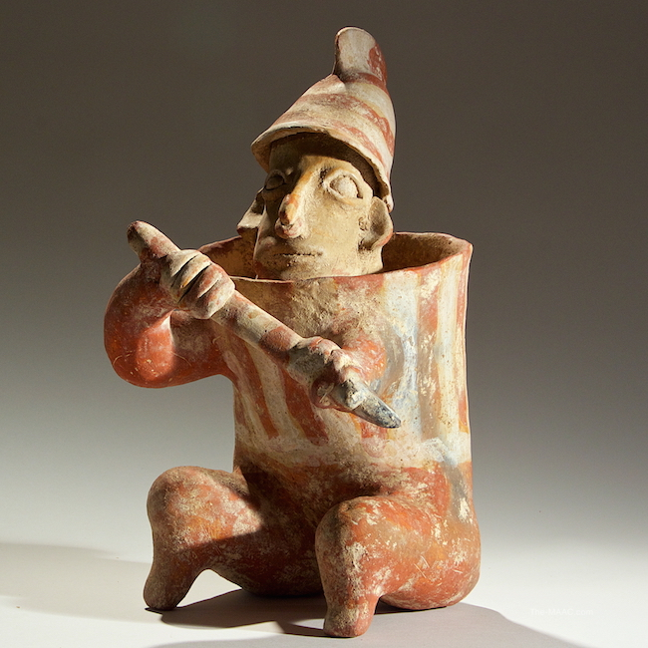

**Case No.: 9**

**Accession No.**

**Formal Label:** Mex-Jalisco-Warrior in Armor-Holding Club-100 BCE

**Display Description:**

The warrior wears a crested helmet, possibly of wood or wicker. Around his body he wears wicker armor, shaped like a cylinder. In his hands he brandishes a club or a short spear. The stance, weapon and armor of the warrior are similar to many found through out the area of the Shaft Tombs. The number of warrior figures found, and the level to which they were armed and armored, indicates that this period in Western Mexico was not entirely peaceful.

These warriors in armor were placed in Jalisco tombs to ward off any who might seek to disturb those interred in these shaft tomb graves. This is an especially large and well-detailed example of this effigy.

**LC Classification:**

**Date or Time Horizon:**

**Geographical Area:**

**Map:**

**GPS coordinates:**

**Cultural Affiliation: Jalisco**

**Medium: ceramic and red pigment**

**Dimensions:** H: 15-3/4 in

**Weight:**

**Condition:**

**Provenance:** [Palmyra Heritage: Gallery 16/212.319.1077]. A 3rd generation family business, open since 1995 in NYC.  Specializing in Ancient Greek, Roman, Byzantine and Islamic coins.  Egyptian, Greek, Rome, Byzantine and Islamic artifacts. Gallery #:  16 Phone #: [212.319.1077](tel://2123191077)

**Discussion:**

The Western Mexico shaft tomb tradition or shaft tomb culture refers to a set of interlocked cultural traits found in the western Mexican states of Jalisco, Nayarit, and, to a lesser extent, Colima to its south. Built beneath house platforms, these tombs served as family mausoleums and were periodically opened to inter the recently deceased.

**References:**